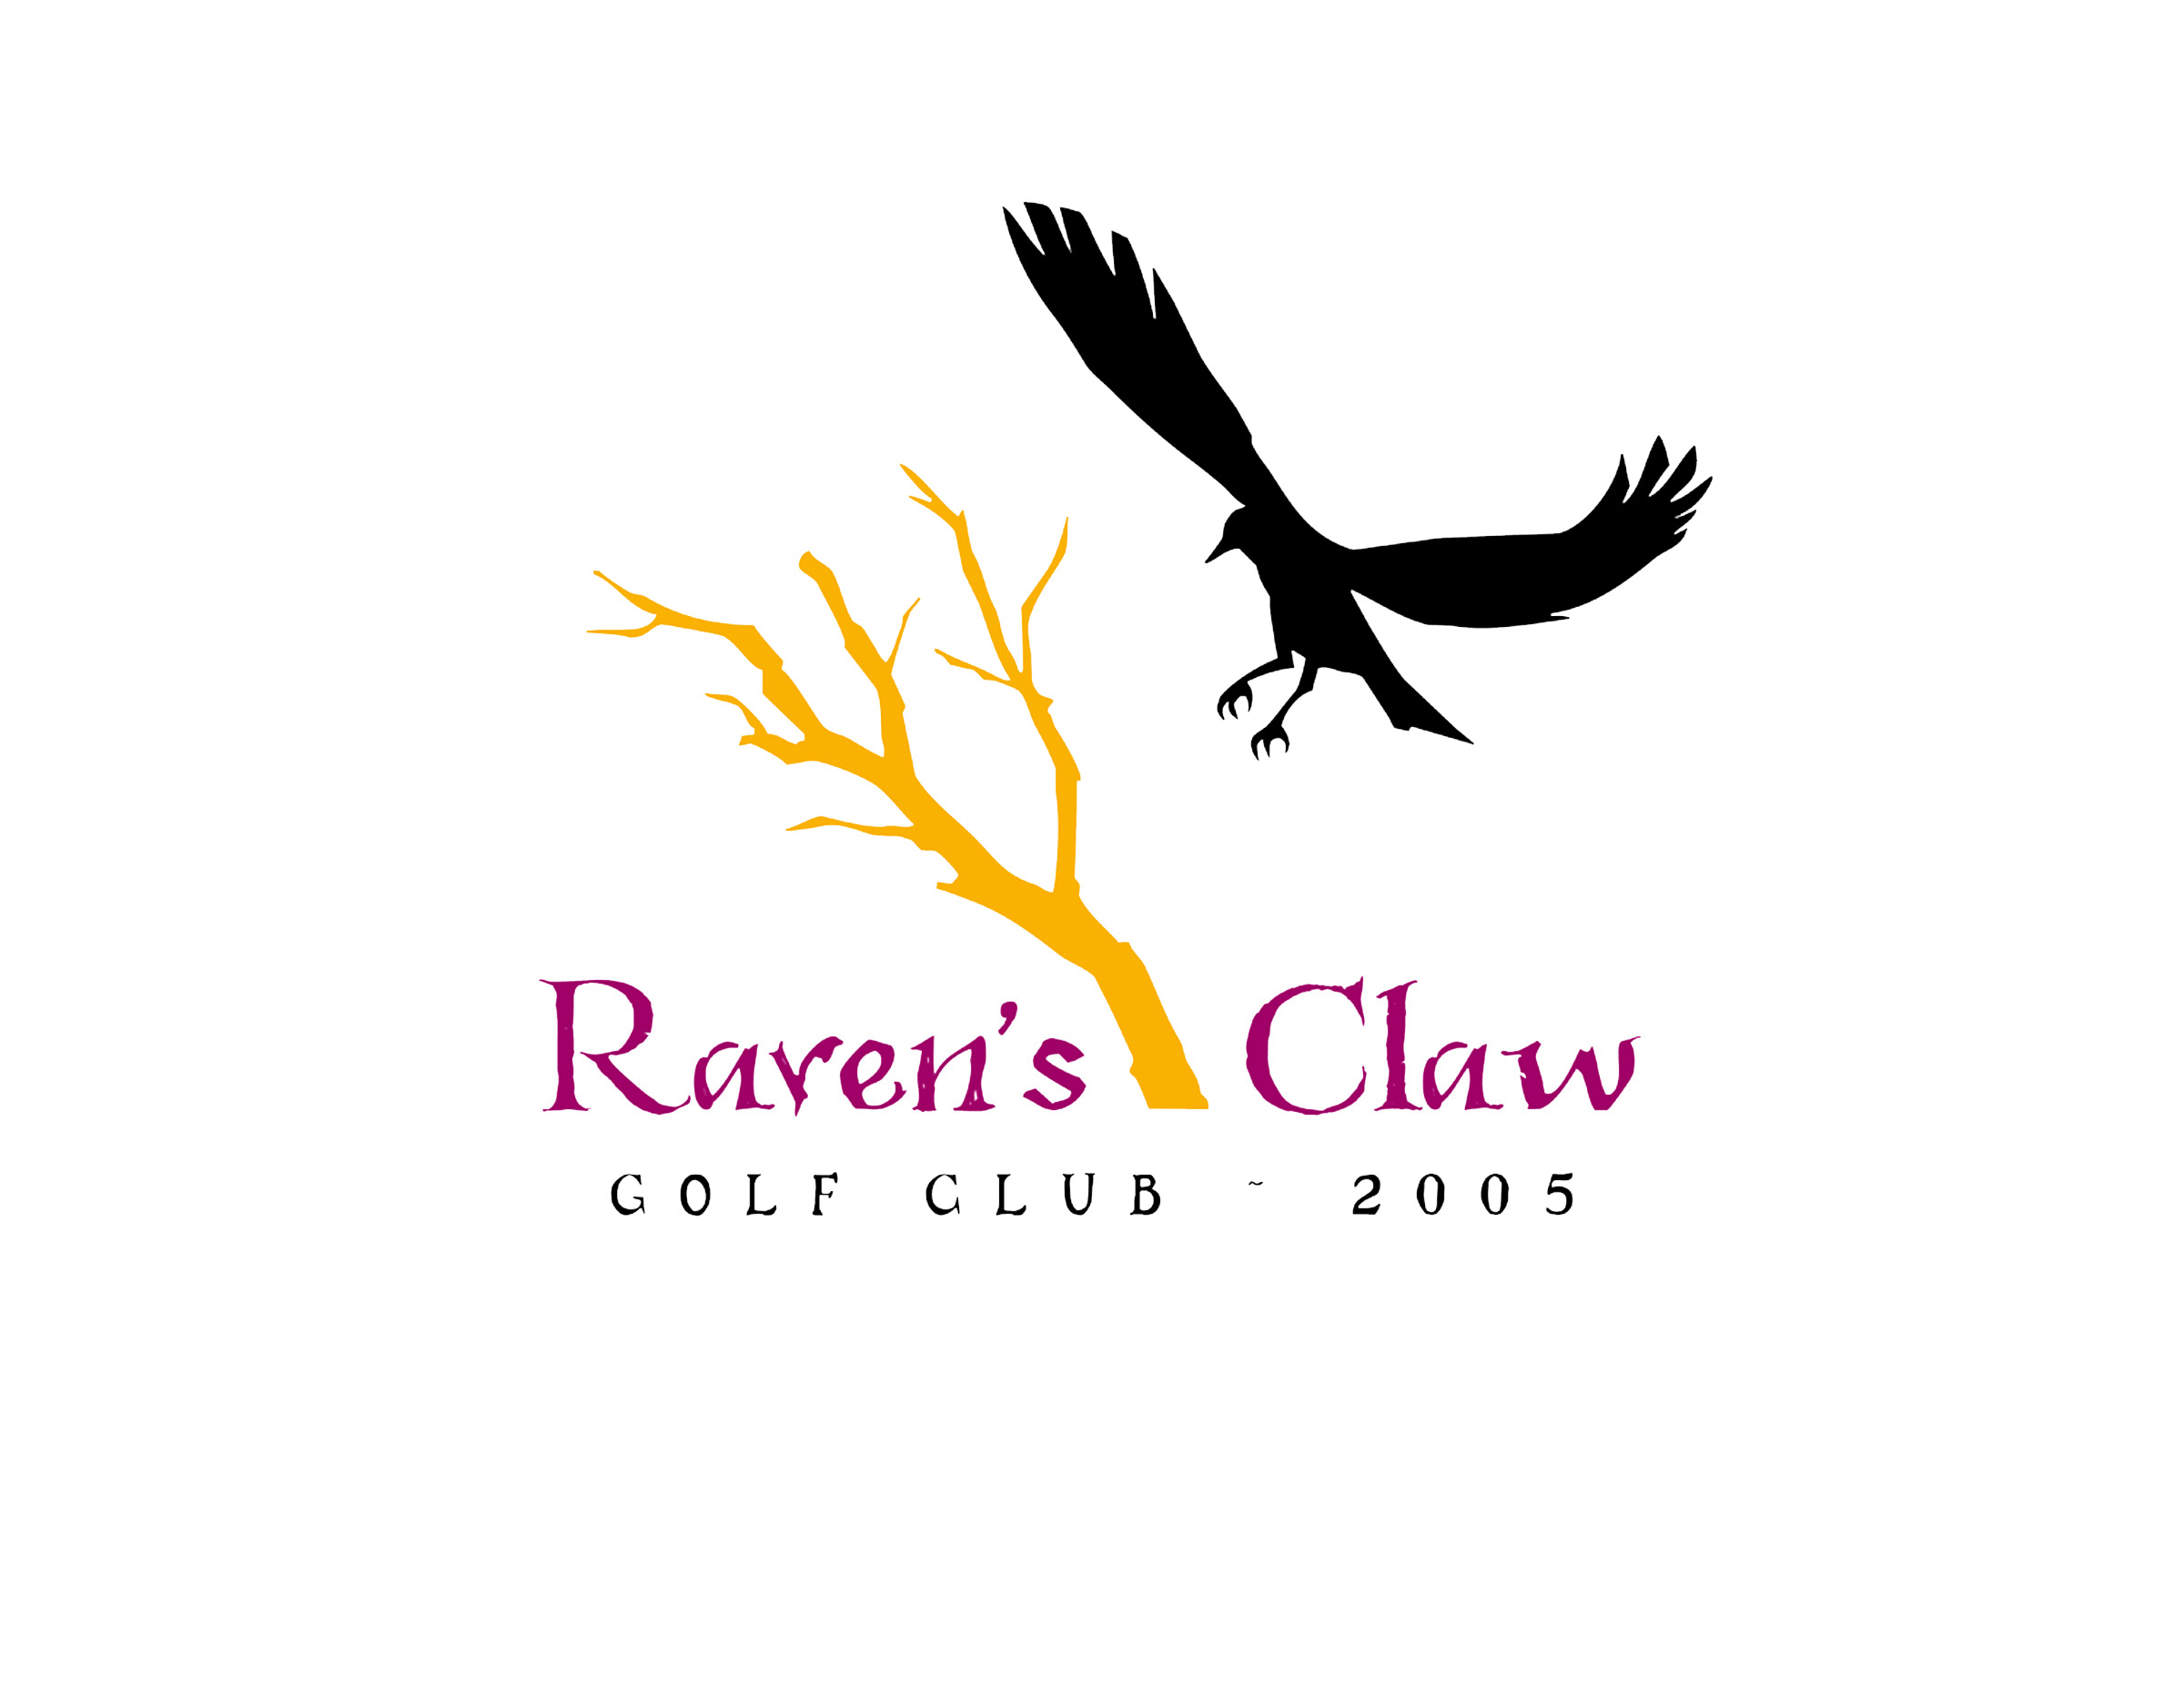
2026 Men’s League
Wednesday Evenings • April 29th – Aug 26th
Some dates subject to cancellation due to tournaments/holidays/weather

Shotgun 5:30 PM – Alternate Front & Back Nine
Sign up Deadline is April 10th, 2026
◦League Registration Fee: $85/ Per Player, Includes League Admin. Software, GHIN Handicap, & End of Year Banquet
◦GHIN Handicap required - Player’s without current HDCP will assigned a handicap.
Handicaps WILL BE ADJUSTED ON A WEEKLY BASIS by League Administrator!
◦Weekly Green Fees: 9 Holes w/ Cart and range balls- $39 per player
◦League Format: 2-Man Better Ball of Partner’s (NET)
◦Singles may sign up to be substitutes for absent league players
The top 8 teams from each division will go into playoffs starting Sept. 2nd.
www.ravensclawgolfclub.com • 610.495.4710
email cgeiger@ravensclawgolfclub.com
2026 Men’s Golf League • Raven’s Claw Golf Club • Entry Form
Please enclose $85 registration fee (Cash*, Check, or Credit Card #)
& bring or mail this entry to:
Raven’s Claw Golf Club, 120 Masters Drive, Pottstown, PA. 19464

Player 1: Player 2:
Address: Address:
City: City:
State: Zip: State: Zip:
Phone # Phone#

Player 1 E-Mail (required)

Player 2 E-Mail (required)

E-Mail Address is required for notifications, cancellations, and future registration purposes.
Your e-mail address will not be used for any other function and will not be sold for advertising.
Please Choose Appropriate Payment: Cash* □ Check Credit Card X
Credit Card Number (if applicable):
_______________________________________ exp_______________
*DO NOT send cash. Pay cash in-person at Raven’s Claw Golf Club Pro Shop.

_______________________________________ exp_______________
*DO NOT send cash. Pay cash in-person at Raven’s Claw Golf Club Pro Shop.

