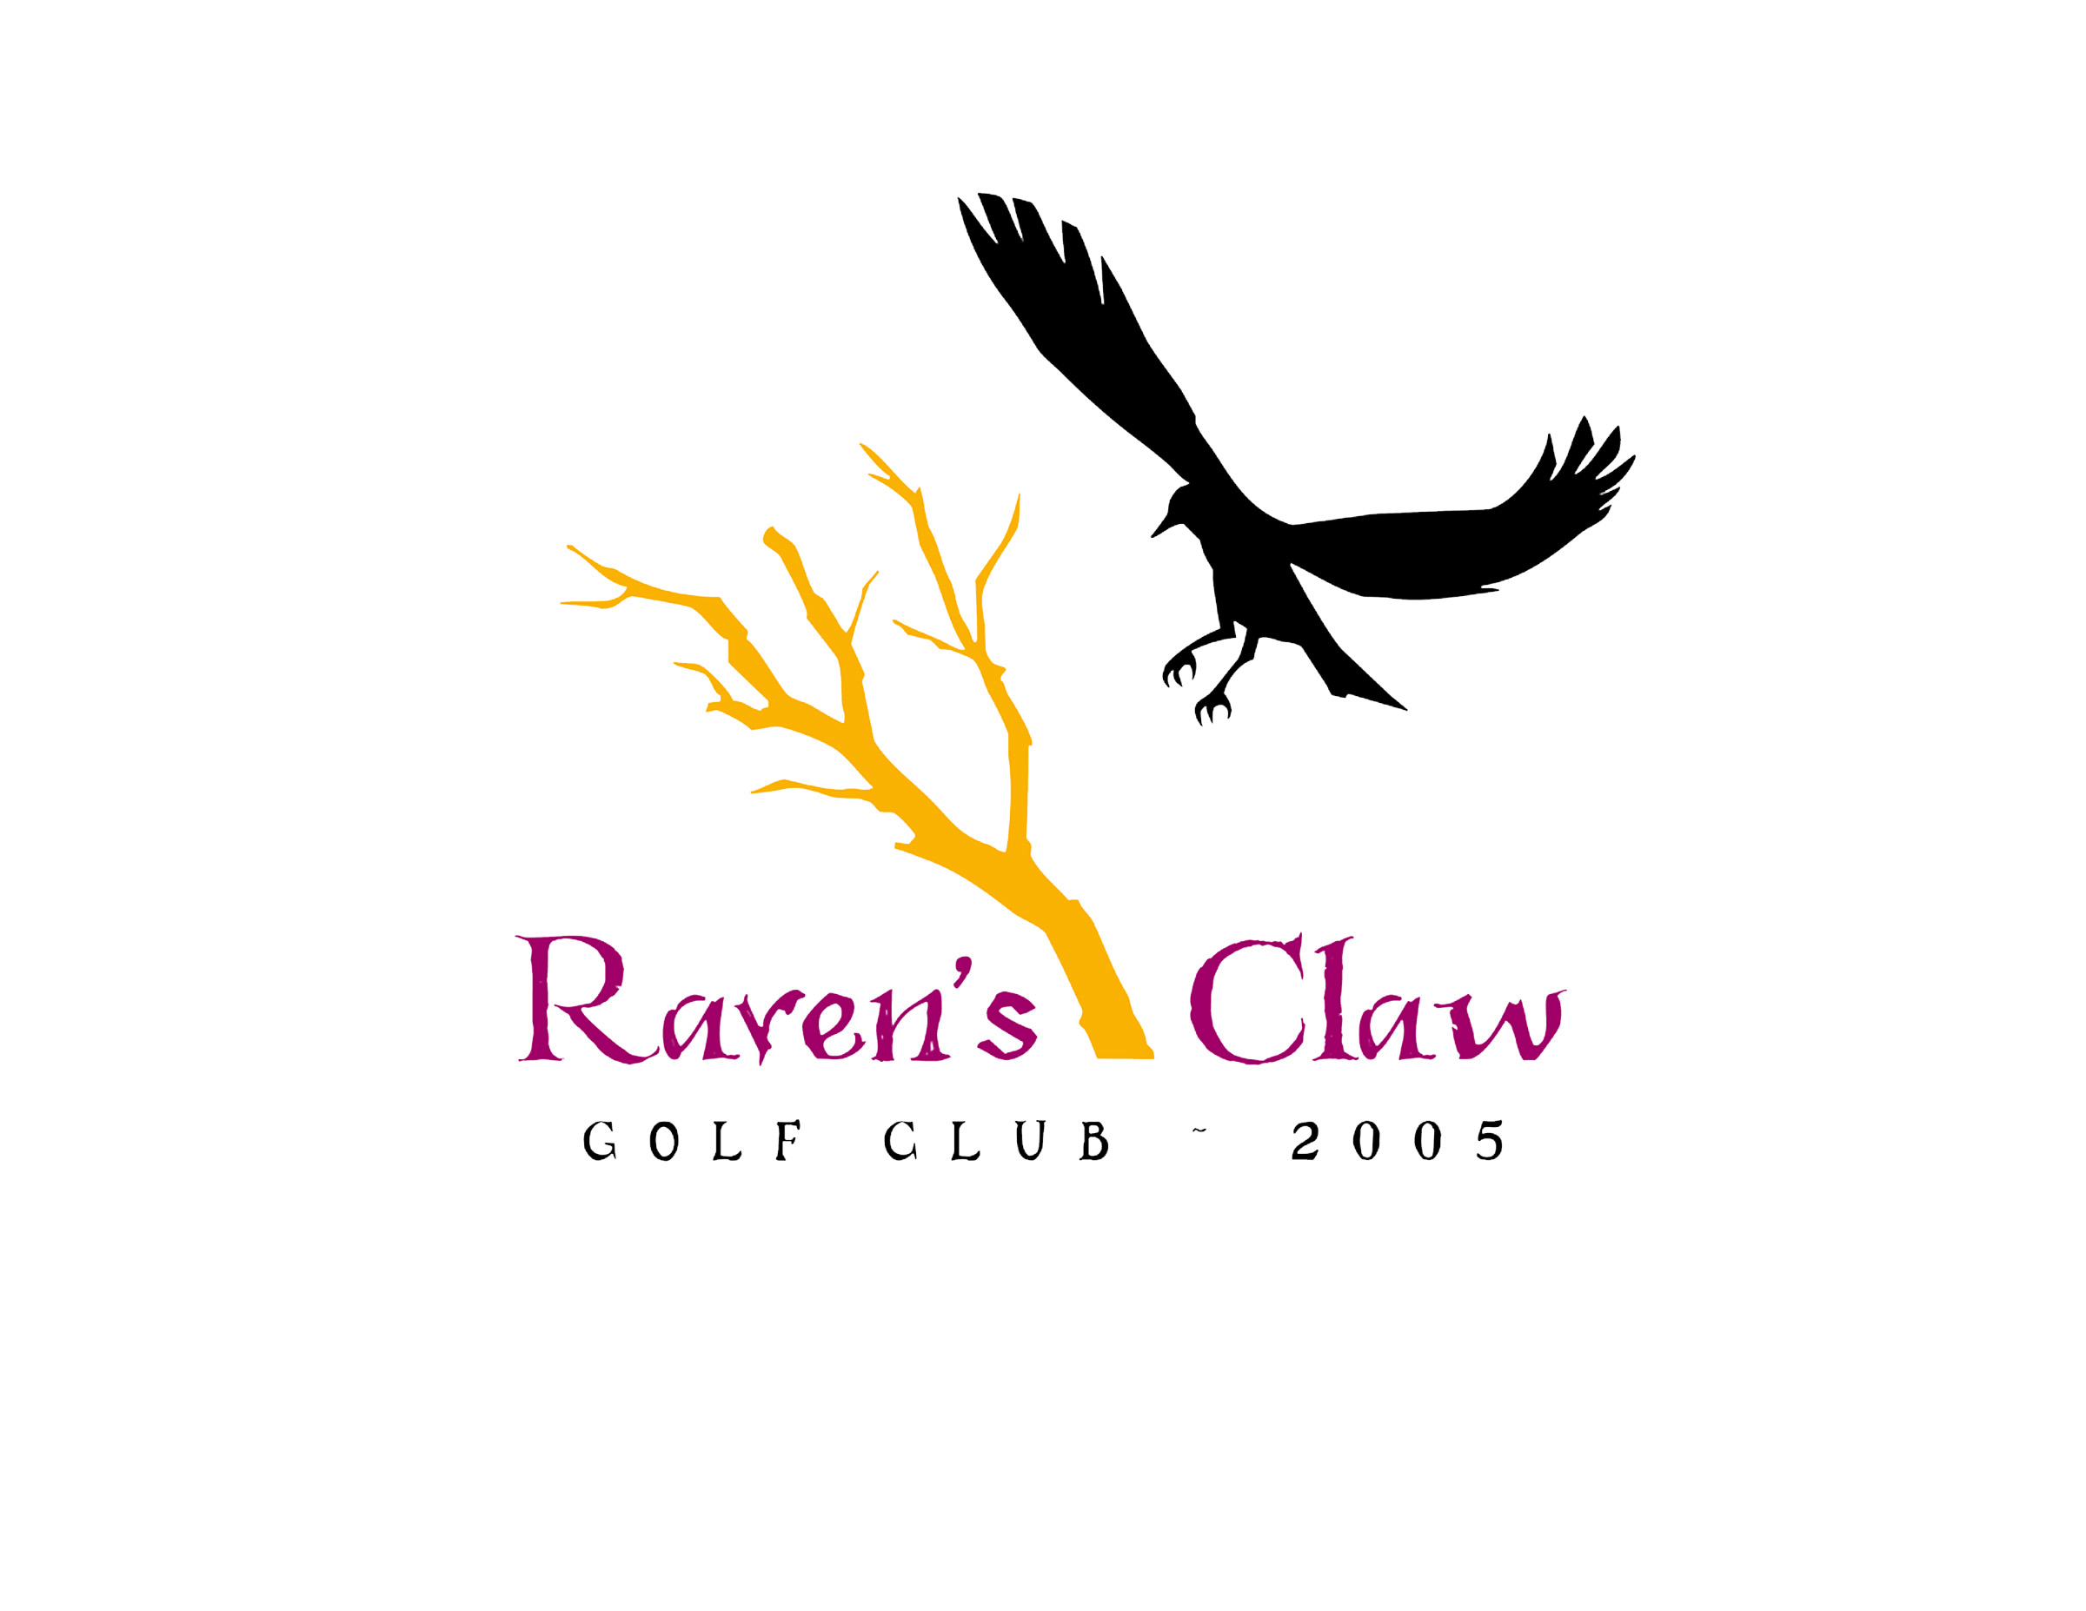
2021 Men’s League
Tuesday, Wednesday & Thursday Evenings • May 4th – Aug 19th
Some dates subject to cancellation due to tournaments/holidays/weather

Tee Times 5:00 to 5:30 PM – Alternate Front & Back Nine
Sign up Deadline is April 27, 2021
◦League Registration Fee: $85/ Per Player, Includes League Admin. Software, GHIN Handicap, & End of Year Banquet
◦GHIN Handicap required - Player’s without current HDCP will assigned a handicap.
Handicaps WILL BE ADJUSTED ON A WEEKLY BASIS by League Administrator!
◦Weekly Green Fees: 9 Holes w/ Cart and range balls- $29 per player
◦Optional $10 Weekly Skins
◦League Format: 2-Man Better Ball of Partner’s
◦Singles may sign up and Pro Shop will make pairings
The top 5 teams from each flight and the defending champion will go into playoffs starting September 1
www.ravensclawgolfclub.com • 610.495.4710
email jbromley@ravensclawgolfclub.com
2021 Men’s Golf League • Raven’s Claw Golf Club • Entry Form
Please enclose $85 registration fee (Cash*, Check, or Credit Card #)
& bring or mail this entry to:
Raven’s Claw Golf Club, 120 Masters Drive, Pottstown, PA. 19464

Player 1 ___________________ Player 2 _____________________ Number from 1 to 3 what night is best for you to play.
Address ___________________ Address _____________________ Tuesday ______
City _______________________City_________________________ Wednesday ______
State _____ Zip _____________ State ______ Zip______________ Thursday ______
Phone # ( ) _____ - _______ Phone# ( ) _____ - __________

Player 1 E-Mail (required) ___________________________________________

Player 2 E-Mail (required) ___________________________________________

E-Mail Address is required for notifications, cancellations, and future registration purposes.
Your e-mail address will not be used for any other function and will not be sold for advertising.
Please Choose Appropriate Payment: Cash* □ Check □ Credit Card □
Credit Card Number (if applicable):
_______________________________________ exp_______________
*DO NOT send cash. Pay cash in-person at Raven’s Claw Golf Club Pro Shop.

_______________________________________ exp_______________
*DO NOT send cash. Pay cash in-person at Raven’s Claw Golf Club Pro Shop.

