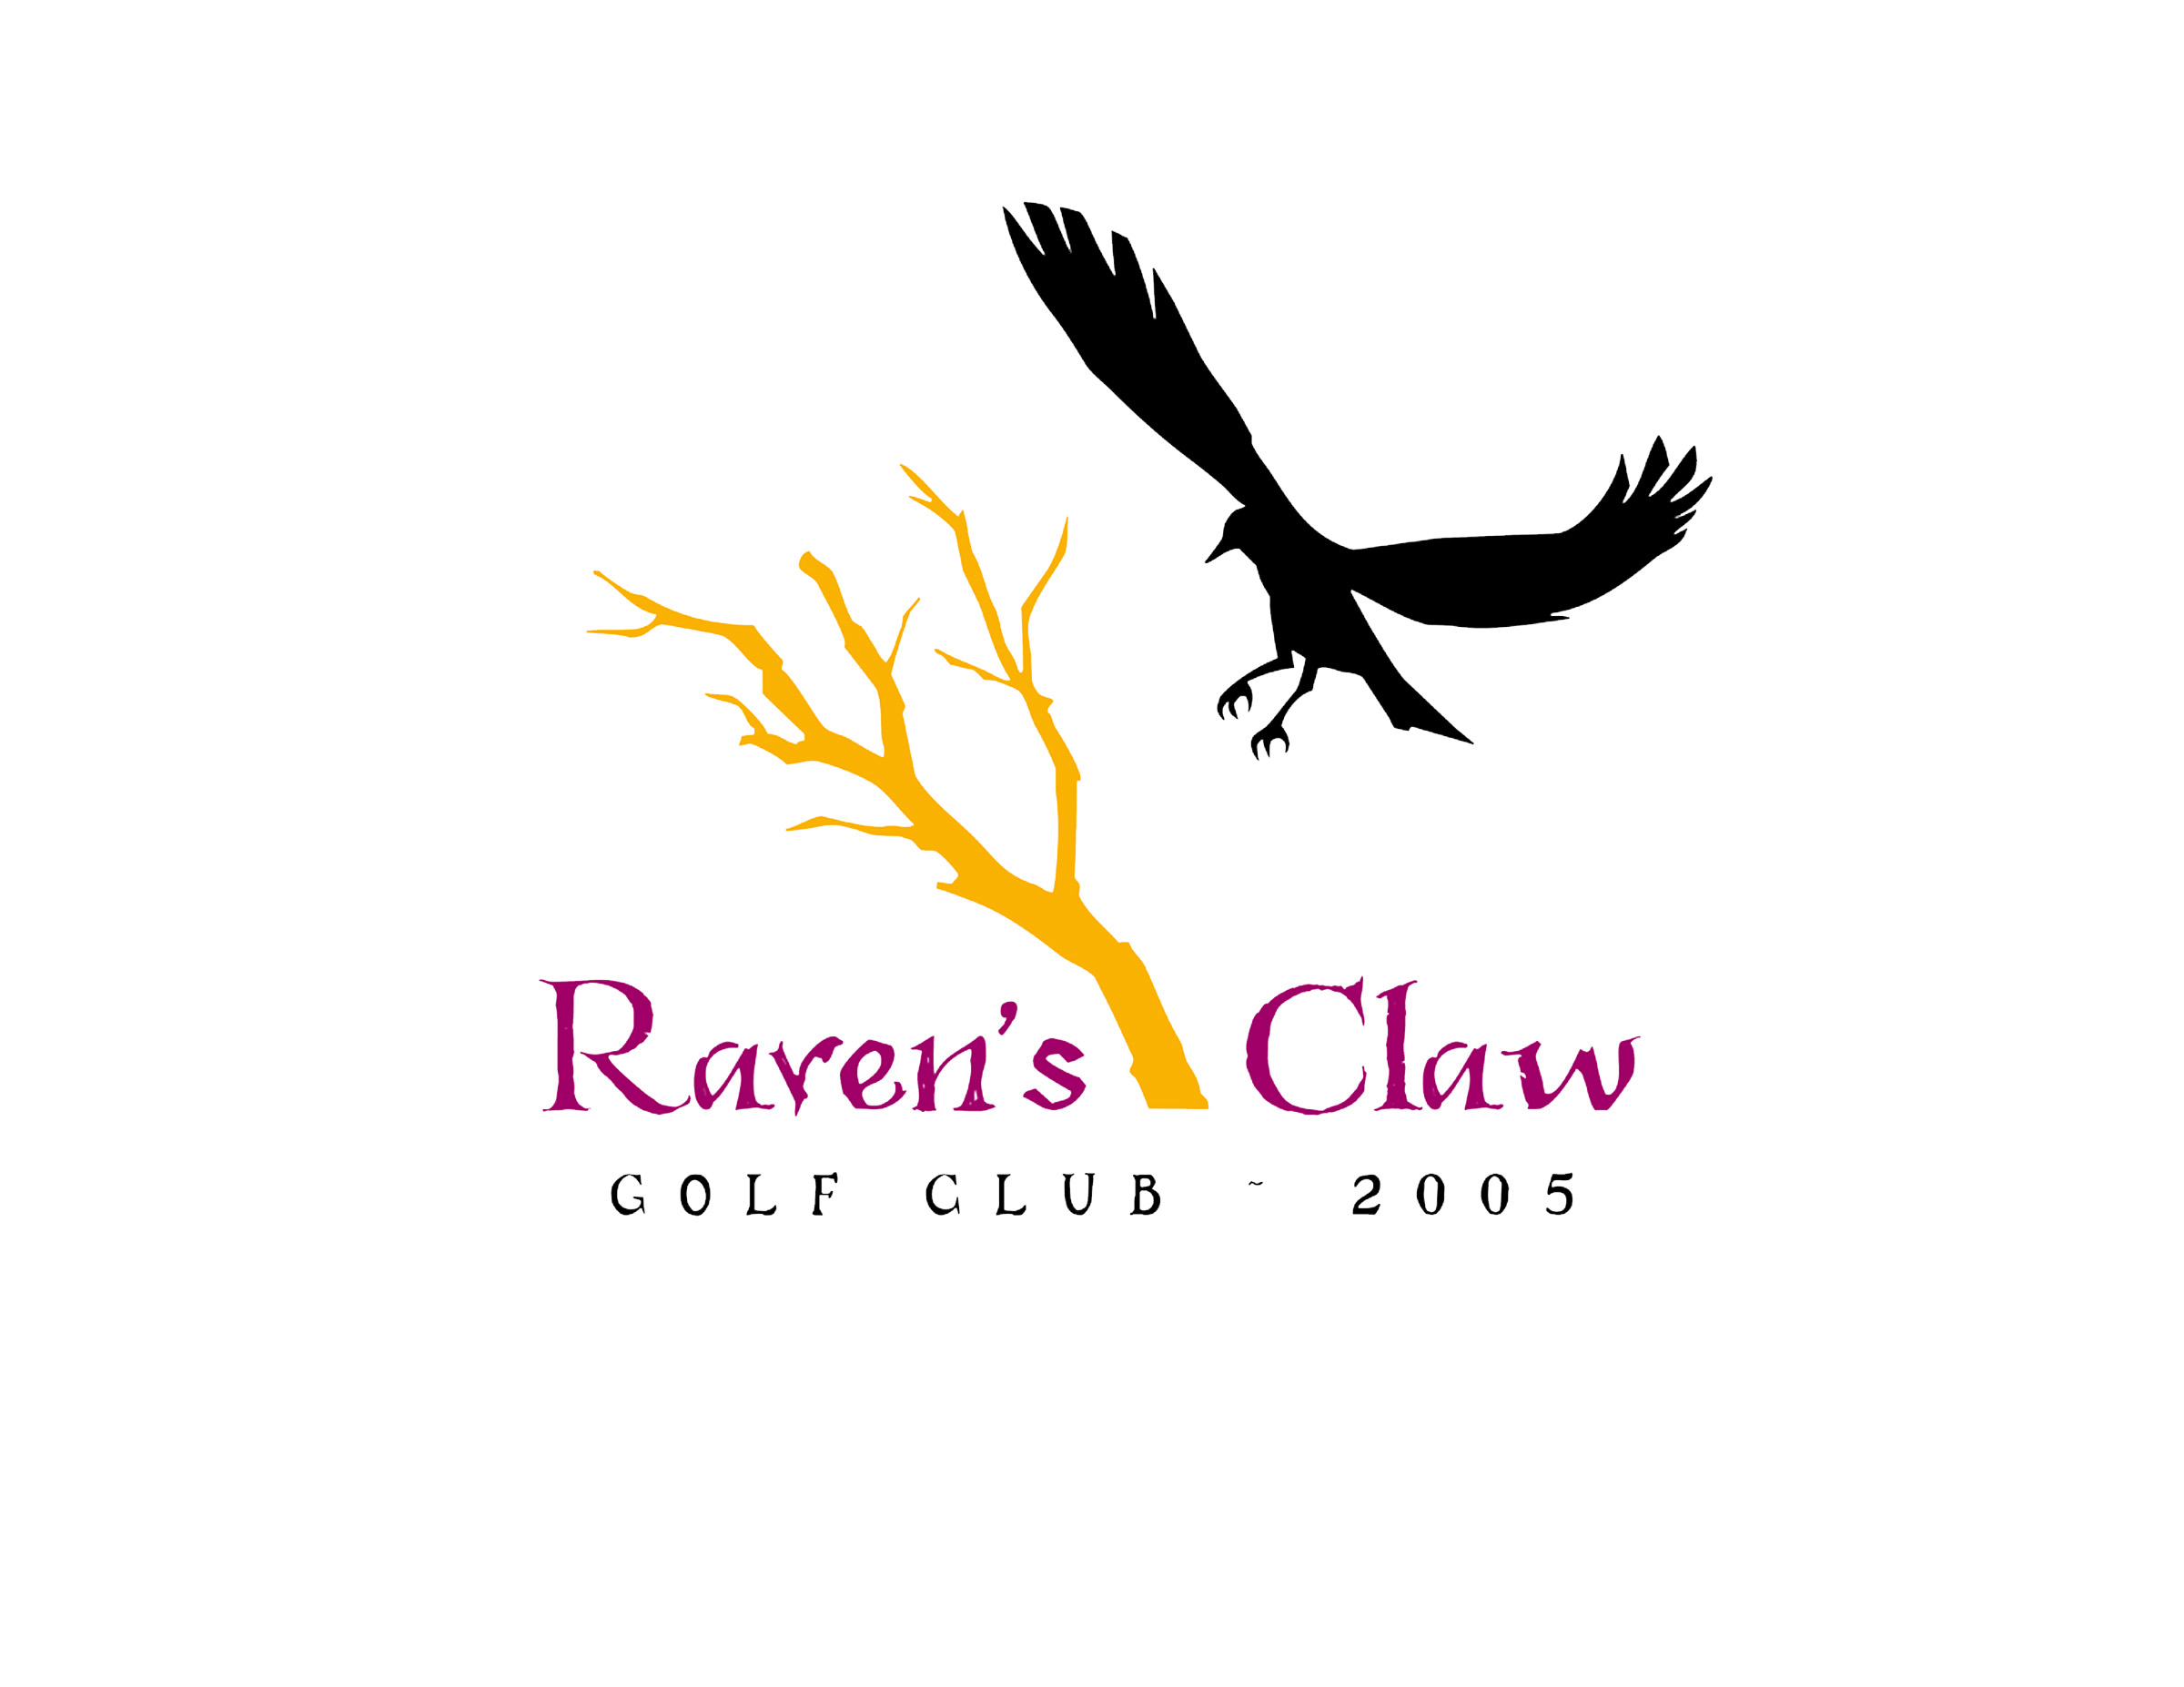
2020 Men’s League
Wednesday Evenings • April 29 – Aug 26th
Some dates subject to cancellation due to tournaments/holidays/weather

Shotgun Start 5:30PM – Alternate Front & Back Nine
Sign up Deadline is April 22, 2020
◦Yearly League Registration Fee: $95/ Per Player, Includes League Administration, GLG Software, GHIN Handicap, Mid-Season & End of Season Banquet
◦GHIN Handicap required - Player’s without current HDCP will start at (12) Course Hdcp. Handicaps WILL BE ADJUSTED ON A WEEKLY BASIS by League Administrator!
Handicaps will be adjusted for exceptional play
◦Weekly Green Fees: 9 Holes w/ Cart - $25 per player
◦Optional $5 Weekly Closest to the Pin & $5 Skins
◦League Format: 2-Man Better Ball of Partner’s
◦Singles may sign up and Pro Shop will make pairings
www.ravensclawgolfclub.com • 610.495.4710
2020 Men’s Golf League • Raven’s Claw Golf Club • Entry Form
Please enclose $95 registration fee (Cash*, Check, or Credit Card #)
& bring or mail this entry to:
Raven’s Claw Golf Club, 120 Masters Drive, Pottstown, PA. 19464

Player 1 ___________________ Player 2 _____________________
Address ___________________ Address _____________________
City _______________________City_________________________
State _____ Zip _____________ State ______ Zip______________
Phone # ( ) _____ - ________ Phone# ( ) _____ - __________

Player 1 E-Mail (required) ___________________________________________

Player 2 E-Mail (required) ___________________________________________

E-Mail Address is required for notifications, cancellations, and future registration purposes.
Your e-mail address will not be used for any other function and will not be sold for advertising.
Please Choose Appropriate Payment: Cash* □ Check □ Credit Card □
Credit Card Number (if applicable):

_______________________________________ exp_______________
*DO NOT send cash. Pay cash in-person at Raven’s Claw Golf Club Pro Shop.

_______________________________________ exp_______________
*DO NOT send cash. Pay cash in-person at Raven’s Claw Golf Club Pro Shop.

